FAQ’s – Caring for a patient with learning disabilities
University Hospitals Bristol supports equal access for adults with Learning Disabilities and Autism to meet their acute health care needs. To enable this all patients with Learning Disabilities or Autism should be referred to the Specialist Nursing Team and must have the Trust Learning Disability and Autism risk assessment and reasonable adjustment forms completed. These documents should then be available for all staff to view in patient notes. Please read these FAQ’s for further information to help you complete these steps and optimise your care of any patients with learning disabilities or autism.
What is a learning disability?
The Department of Health (2001) defines learning disability as “a significantly reduced ability to understand new or complex information, to learn new skills (impaired intelligence) along with a reduced ability to cope independently (impaired social functioning) which started before adulthood, with a lasting effect on development”

What do I need to know about patients with learning disabilities (PWLD) in the context of adult healthcare?
There are around 1.4 million people in the UK with a learning disability. The Confidential Inquiry into premature deaths of people with learning disabilities (2013) (PWLD) found that adults with a learning disability die 13 – 20 years younger than the general population and 26% of PWLD are admitted to general hospitals each year compared to 14% of the general population the most common immediate causes of death in PWLD are respiratory problems and heart and circulatory disorders. In order to ensure that PWLD are given equal to access to and during their stay in acute services, guidance around reasonable adjustments of care delivery set out in the Equalities Act (2010) must be at the forefront of care, as markers of good practice and quality standards.

What do I need to do?
- Complete a Medway Service Order which now includes a section for reasonable adjustments within 48 hours
- Ensure a care plan for PWLD is in place
- Complete a Hospital Passport

Why do I need to complete the Medway Service Order?
The Learning disabilities team should be aware of all PWLD to help support them and staff as required; the Medway Service Order will ensure this happens. The aim is for staff caring for a PWLD to identify any specific care needs that may be presented and to make reasonable adjustments if needed at the earliest opportunity – the Medway Service Order will help ensure this happens.
What is a ‘reasonable adjustment?
A reasonable adjustment is considering patient care and involves removing or adjusting any potential barriers individuals may face when accessing acute care and to help identity the needs of the individual in order to ensure their health care needs can be met appropriately.

How do I complete a Medway Service Order?
Log onto Medway, select the patient, enter the ‘Clinical Info’ tab and go to ‘Service Orders’ :

Select the Adult Learning Disabilities and/or Autism Liaison Team Order and then follow the on-screen instructions:

What is the Hospital Passport?
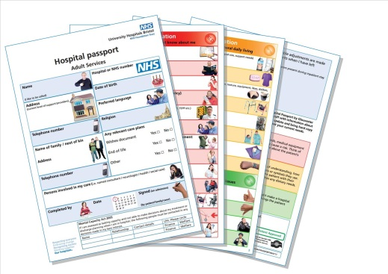
Please make use of the trusts hospital passport document as a way of finding out information about a patient who may struggle to express their needs.
A copy can be found on the external website and on the Learning disability connect page Connect>Quality and Patient Safety>Safeguarding Adults and Children and Mental Capacity>Learning Disabilities. PWLD/their family/carers should be encouraged to complete one. A copy of the Hospital Passport should be kept on the ward and also a copy given to the family / carers.

Should ALL patients admitted to UHB with Learning Disabilities or Autism have a Hospital Passport?
Further information can be found at Connect>Quality and Patient Safety>Safeguarding Adults and Children and Mental Capacity>Learning Disabilities including a Hospital Passport Guide for patients and visitors.

