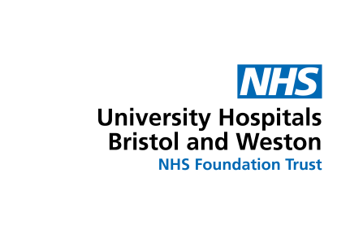
Adult patient publicity consent form
I....................................................................................................................................................................................
of..................................................................................................................................................................................
......................................................................................................................................... (address)............................

give my consent to be interviewed / filmed / photographed (delete as appropriate) by

media...South Wales and South West Congenital Heart Disease Network…………………………………………………

date.................................................................................................................................................................................

purpose...Congenital Heart Disease Network social media / publications / website.....................................................

I understand that:

My participation in this photography / interview / sound recording / broadcast (delete as appropriate) is voluntary and that I may withdraw consent at any time during the interview / photography/ filming.

I give this consent freely without the expectation that I will have more or better care and treatment from the NHS because of my participation.

My consent allows THE SOUTH WALES AND SOUTH WEST CONGENITAL HEART DISEASE NETWORK (or a third party connected with the company) to use these photographs / interview and any footage / sound recording of me / my voice / my image (delete as appropriate). These could be used in publications, on websites, social media pages or in any other form or medium anywhere in the world, which may include the transfer of personal data outside of the European Economic Area.

I may at any time withdraw my consent to the use of the interview / photographs / footage / sound recordings (delete as appropriate) but that once published into the public domain such withdrawal may not affect material already published for the purpose stated above

Once the photography/ interview/ filming (delete as appropriate) is complete the rights belong to:
The South Wales and South West Congenital Heart Disease Network…………………………………………………….

University Hospitals Bristol and Weston NHS Foundation Trust cannot control the use or disclosure of information about me relating to this photography / interview / filming (delete as appropriate) once published and I accept that the Trust is not liable for the use or disclosure of information relating to the broadcast / article / website / publication (delete as appropriate) for which I have agreed to participate.

The Trust will keep the media for a period of three years and then securely delete or destroy it. This shall not apply to any portions published into the public domain.

I can find further information about my rights and how the Trust looks after my personal data at www.uhbw.nhs.uk/p/privacy-statement
Signed............................................................................................................................................
Contact number and email address...............................................................................................
Staff involved in arranging..............................................................................................................
Ward / location................................................................................................................................

